Trait Purity 2022 Proficiency Test
Fill in the Blank
1. Adventitious presence as the _____________ or _______________presence of another seed variety or genetic material, and/or trait(s) from another variety as a result of natural, mechanical or human means.
2. Lateral Flow Strips are a ________________________ test.
3. Non-herbicide tolerance traits such as insect resistance are often tested via an immunoassay utilizing either__________________________and/or ________________ methods.
4. Molecular methods, including SNPs, may be used to test for trait purity for all defined traits including _________ tolerance, _________ resistance, and ___________ tolerance.
5. Herbicide tolerance traits can be categorized as _____________ modified or ___________ occurring.
6. Herbicide concentrations are typically expressed in parts per million (ppm) in lab test applications. Parts per million is ______________ and is similar to a _____________.
7. The use of check (or control) seed for each sample tested is essential to assure test accuracy and limit laboratory liability. Both ____________ and ___________ trait check samples should be included.
8. Immunoglobin is another name for___________________.
9. Element Specific AP testing could target the _____________ and ________________ sequences associated with many GMO events.
10. A typical ELISA kit purchased from a vendor contains the plate, _____________,_______________ and __________.
11. SNPs are powerful genomic markers that assess a lines ____________ and ______________.

True/False
12. True False Trait testing is regulated by the Federal Seed Act
13. True False The main advantage to herbicide bioassay is cost.
14. True False Lateral Flow Strips can be used to measure both AP and Trait Confirmation.

Short Answer
15. What four technologies can be used for trait detection?
a
b
c
d
16. What is the difference between Quantitative PCR and Qualitative PCR?

17. Please name two advantages of using Quantitative PCR for trait testing.

18. Name two reasons why Lateral Flow strips are advantageous.

19. Trait impurities are often due to contaminations cause by (name two)
a.
b.

20. What is the differences between Polyclonal Antibodies and Monoclonal Antibodies?

21. In an ELISA test what would be three reasons that there is no color present in the wells at the end of the test?
a.
b.
c.

22. Name the three methods used for Herbicide Bioassay tests.
a.
b.
c.

23. Non-Trait Monocot seedling will commonly express what symptoms?

24. In a greenhouse spray test the plant affected by the herbicide show what symptoms?

25. If your negative control shows no sensitivity to herbicide at the end of a test what would be the reason? Please name 3.
a.
b.
c.

26. Name the four nitrogenous bases for deoxyribonucleotide triphosphates.
a
b
c
d

Multiple Choice
27. False positive or negative for lateral flow strips can be caused by?
a. wrong sample buffer
b. Strips submerged too deep in the samples extract
c. A and B
d. None of the above.
28. Edge Effect on ELISA plates is cause by?
a. Stacking of plates.
b. Strong light
c. Cold plates or reagents
d. All of the above.
29. Match the technology on the left with what it detects on the right side.
a. PCR Protein
b. Bioassay DNA
c. Immunoassay Trait
Calculations
30. Use Seedcalc8 to calculate the % contamination and upper bound true % purity in a sample using the information below.
# of seed pools - 30
# of seeds per pool- 1000
# of deviant pools 15
Desired confidence level 95%
____________% contamination _____________upper bound true % purity
31. Use Seedcalc8 to calculate the % contamination and lower bound true % purity in a sample using the information below.
# of seed pools- 20
# of seeds per pool- 500
# of deviant pools- 8
Desired confidence level 95%
____________% contamination _____________lower bound true % purity
32. Calculate the ppm for the Herbicide Concentration of Roundup Ultra 41%.

33. In this picture of the 2,4,D Soybeans rate each plant as normal or abnormal and tolerant versus non tolerant.
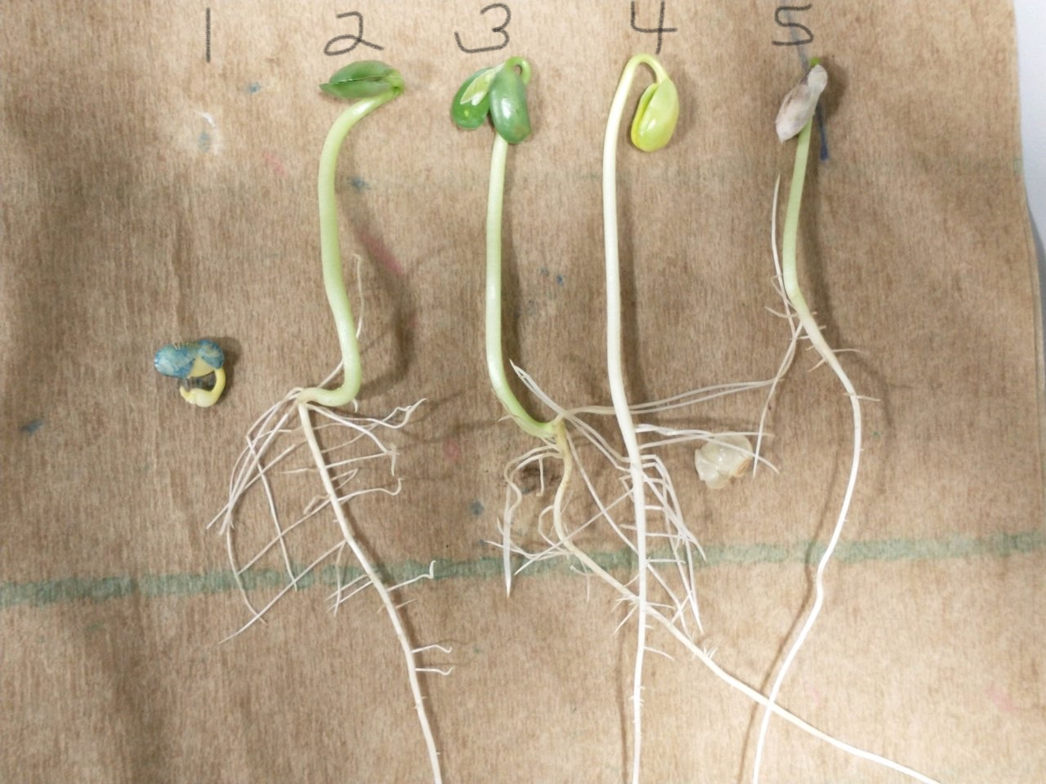

1. ___normal ____abnormal ____tolerant _____nontolerant
2. ___normal ____abnormal ____tolerant _____nontolerant
3. ___normal ____abnormal ____tolerant _____nontolerant
4. ___normal ____abnormal ____tolerant _____nontolerant
5. ___normal ____abnormal ____tolerant _____nontolerant

34. In this picture of Liberty Corn rate each plant as normal or abnormal and tolerant versus non tolerant.
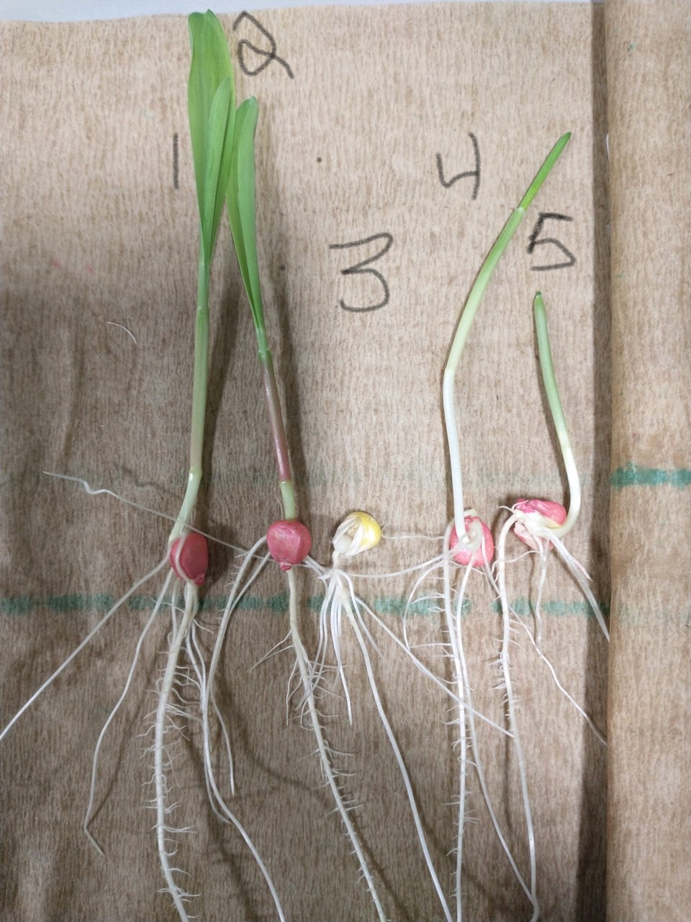

1. ___normal ____abnormal ____tolerant _____nontolerant
2. ___normal ____abnormal ____tolerant _____nontolerant
3. ___normal ____abnormal ____tolerant _____nontolerant
4. ___normal ____abnormal ____tolerant _____nontolerant
5. ___normal ____abnormal ____tolerant _____nontolerant

35. In this picture of Liberty Soybeans rate each plant as normal or abnormal and tolerant versus non tolerant.
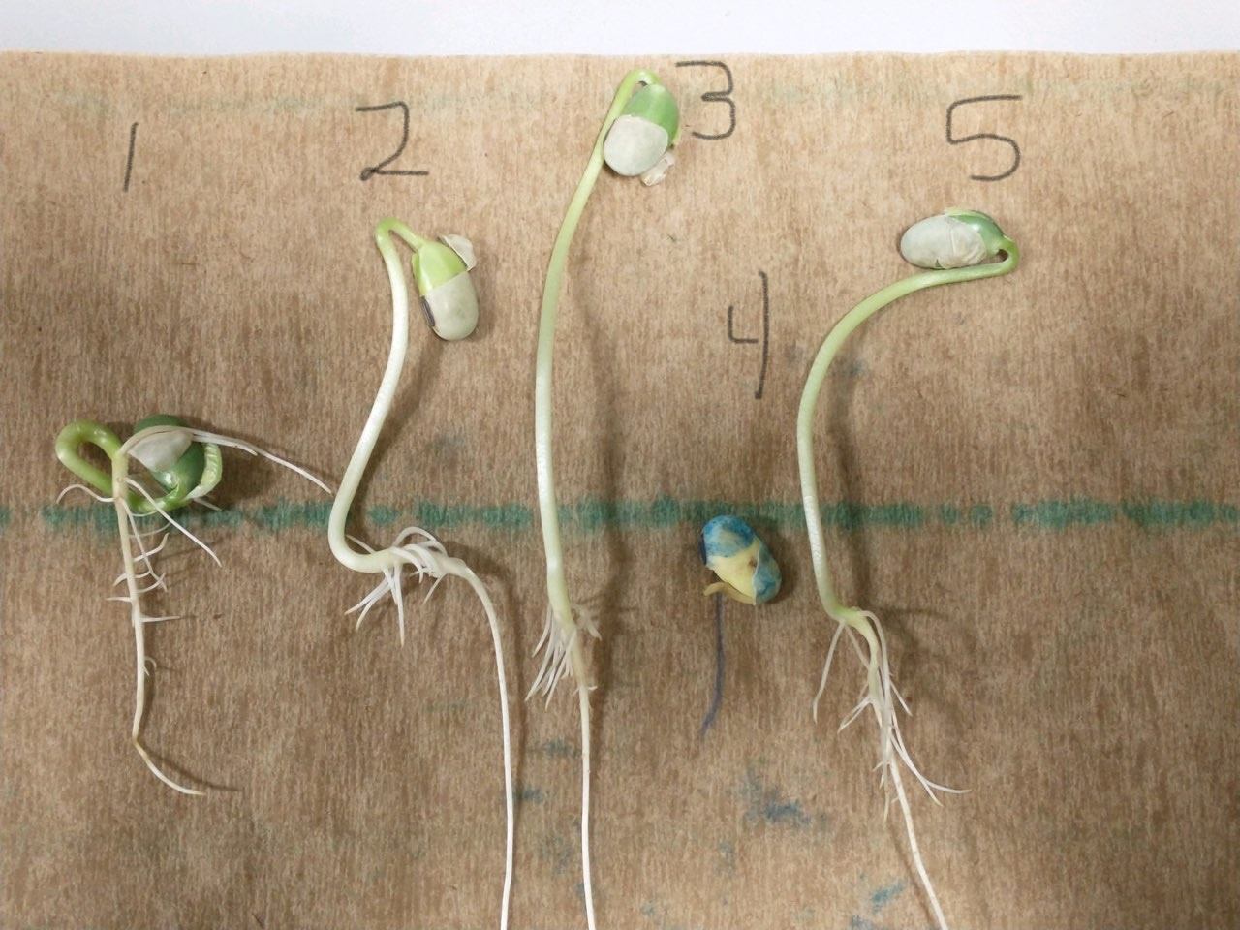
1. ___normal ____abnormal ____tolerant _____nontolerant
2. ___normal ____abnormal ____tolerant _____nontolerant
3. ___normal ____abnormal ____tolerant _____nontolerant
4. ___normal ____abnormal ____tolerant _____nontolerant
5. ___normal ____abnormal ____tolerant _____nontolerant
36. In this picture of Round Up Corn rate each plant as normal or abnormal and tolerant versus non tolerant.
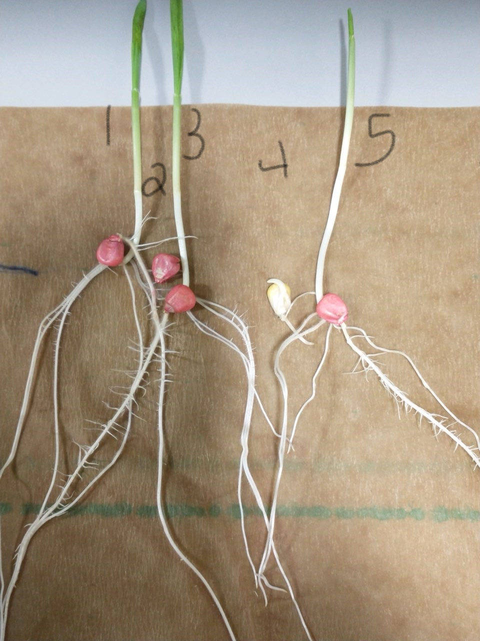
1. ___normal ____abnormal ____tolerant _____nontolerant
2. ___normal ____abnormal ____tolerant _____nontolerant
3. ___normal ____abnormal ____tolerant _____nontolerant
4. ___normal ____abnormal ____tolerant _____nontolerant
5. ___normal ____abnormal ____tolerant _____nontolerant

37. What is the parts per million of the AI on the herbicide listed below?
_________PPM
