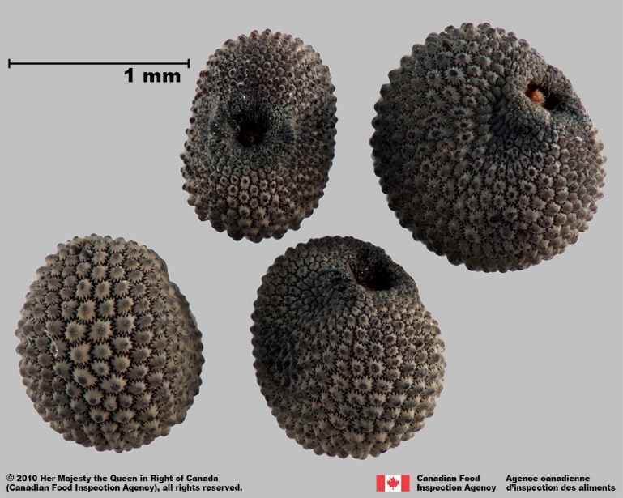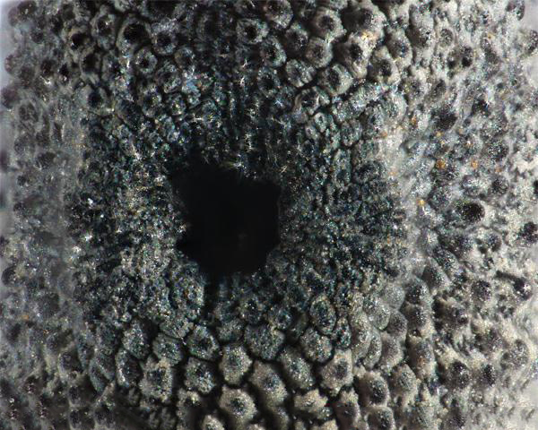

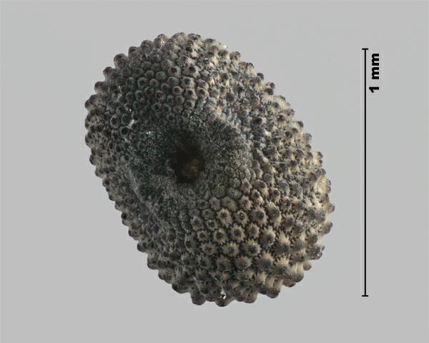

1.

When found in a sample of alfalfa it is:
2. a. weed seed
b. crop seed
c. noxious weed

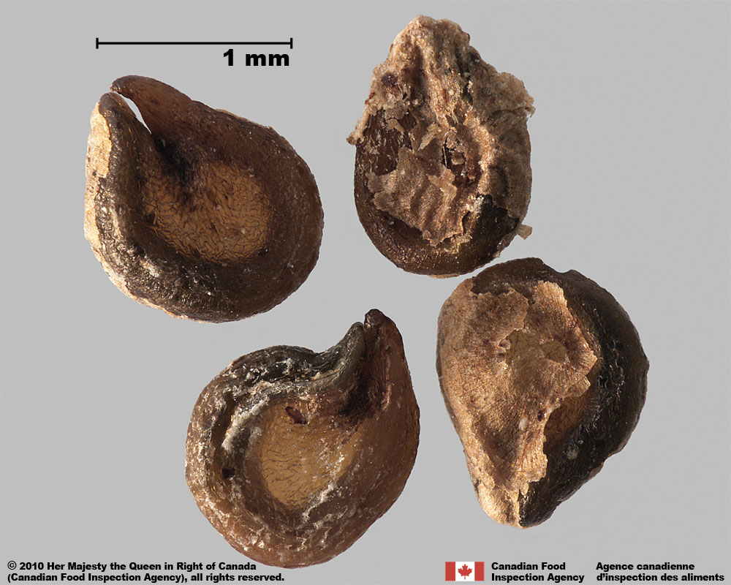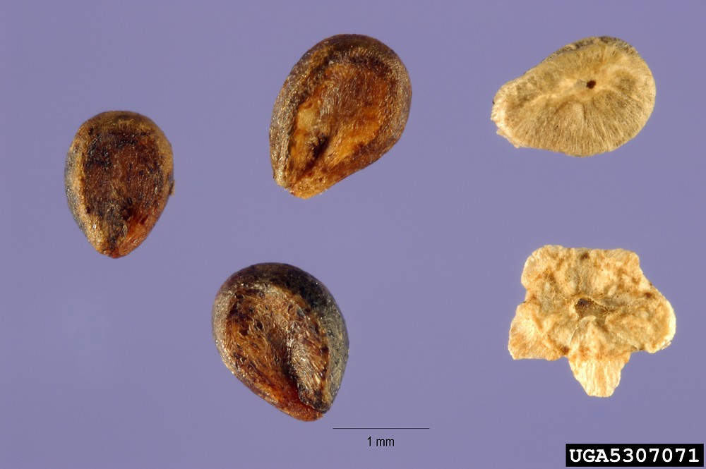

3.

When found in a sample of proso millet it is:
4. a. weed seed
b. crop seed
c. noxious weed

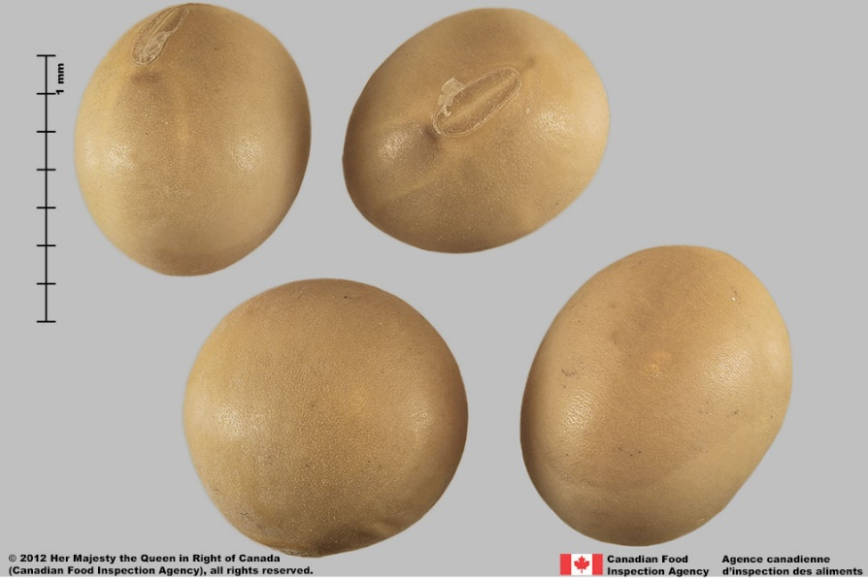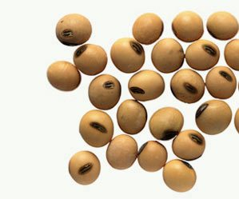

5.

When found in a sample of field peas it is:
6. a. weed seed
b. crop seed
c. noxious weed

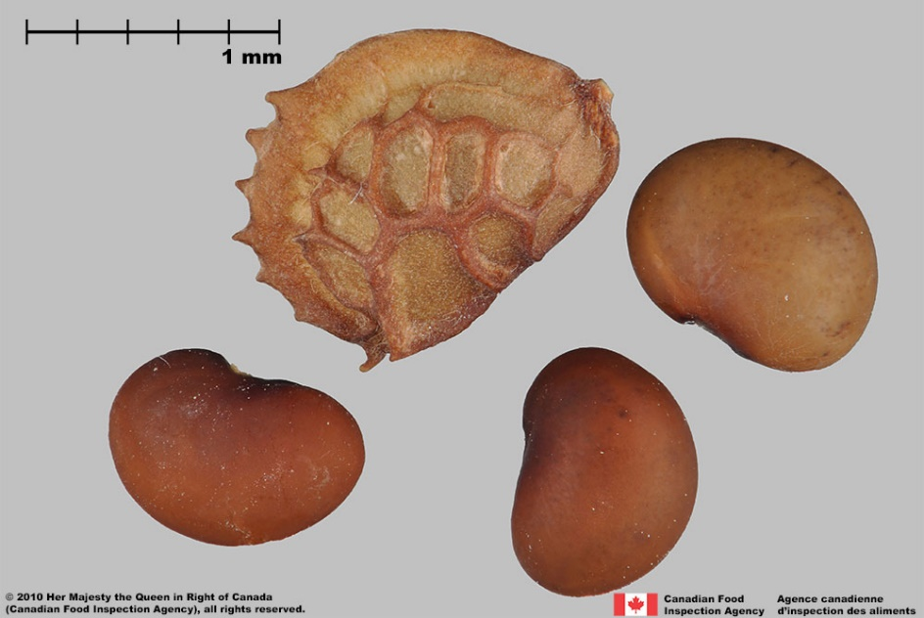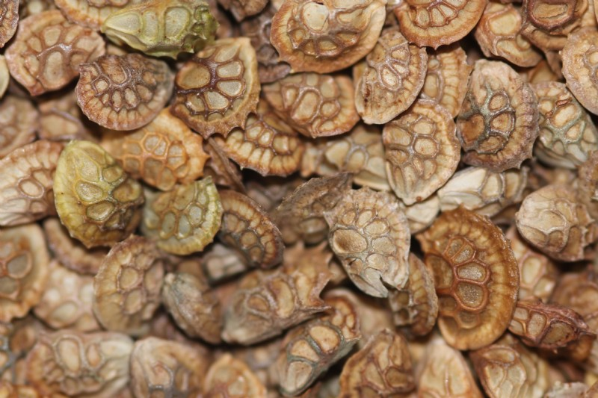

7.

When this seed is found in a sample of alfalfa it is:
8. a. weed seed
b. crop seed
c. noxious weed

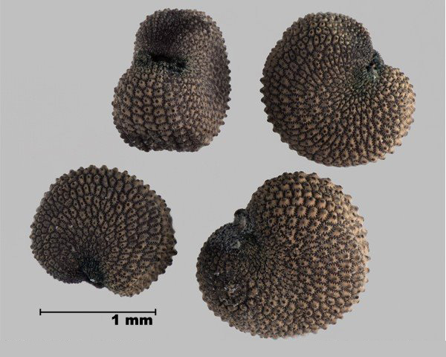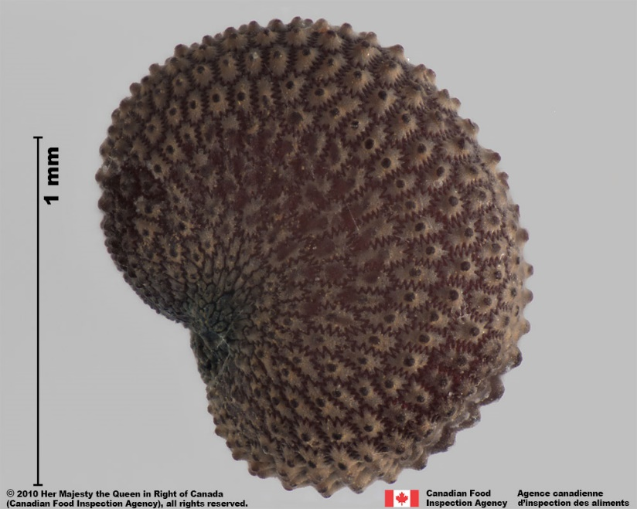

9.

When this seed is found in a sample of red clover it is:
10. a. weed seed
b. crop seed
c. noxious weed

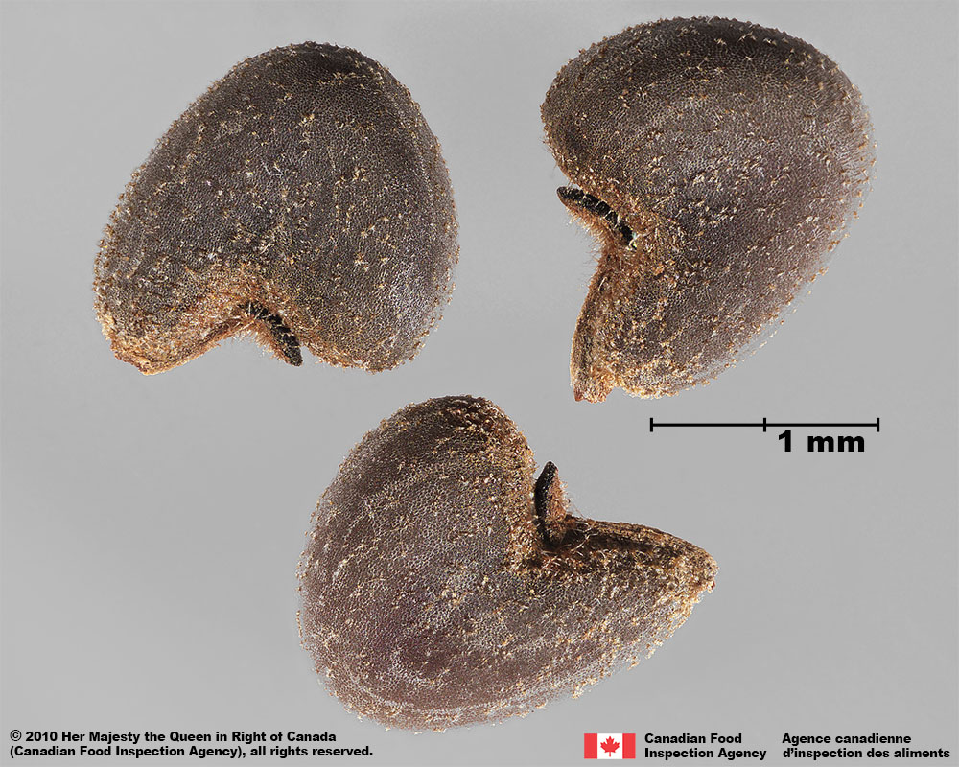

11.

When this seed is found in a sample of corn it is:
12. a. weed seed
b. crop seed
c. noxious weed

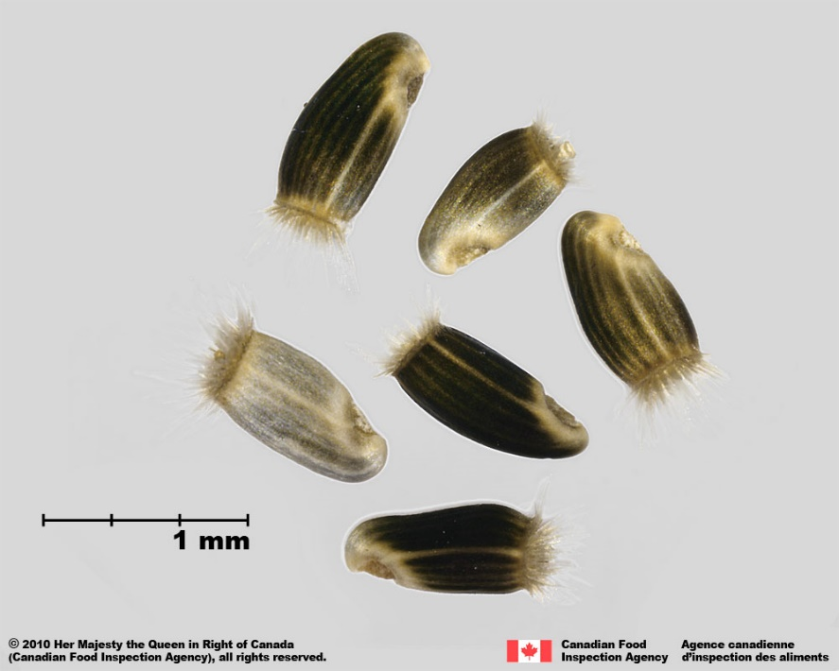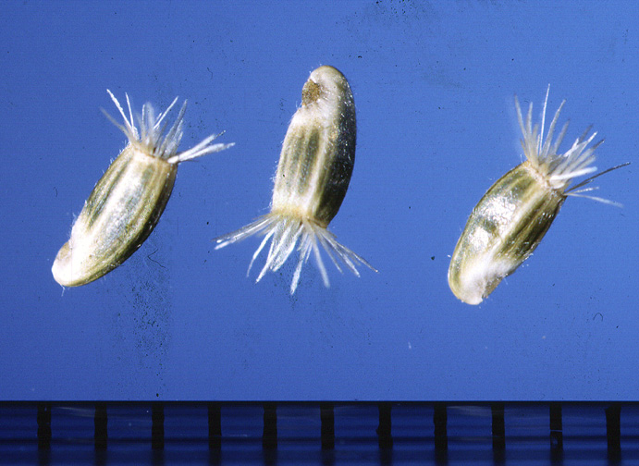

13.

When this seed is found in a sample of wheat it is:
14. a. weed seed
b. crop seed
c. noxious weed

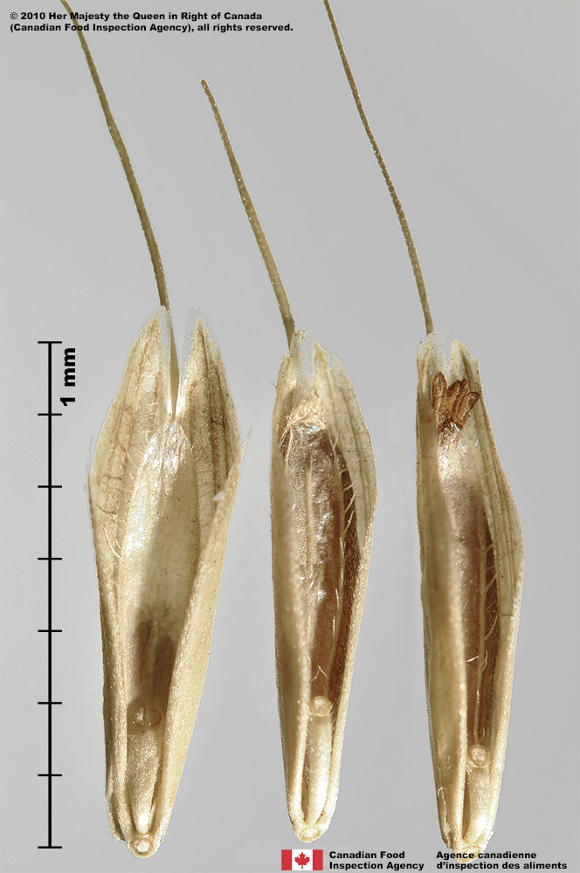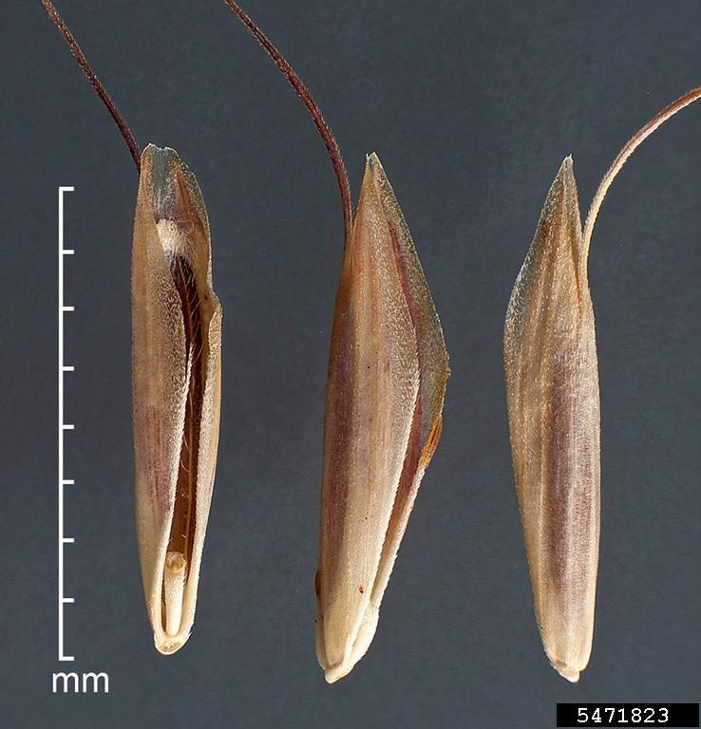

15.

When this seed is found in a sample of a grass mixture composes of tall fescue, ryegrass, brome, and orchardgrass it is:
16. a. weed seed
b. crop seed
c. noxious weed

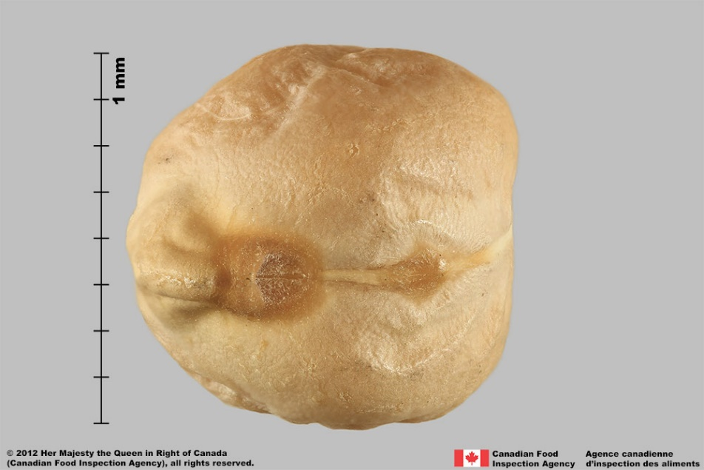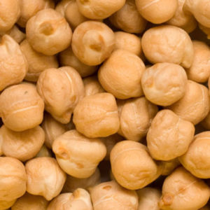

17.

When this seed is found in a sample of field beans it is:
18. a. weed seed
b. crop seed
c. noxious weed

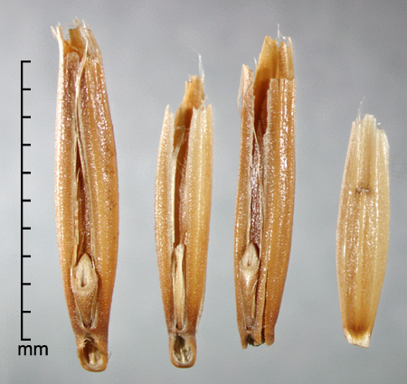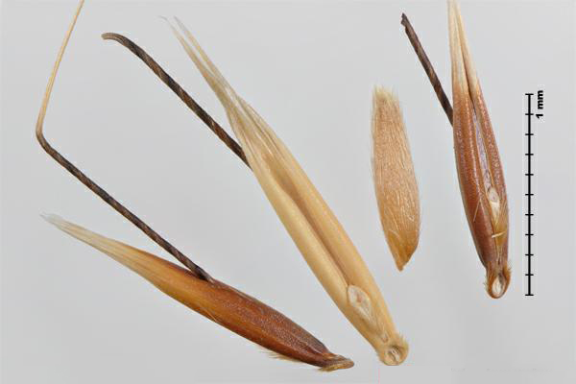

19.

When this seed is found in a sample of oats it is:
20. a. weed seed
b. crop seed
c. noxious weed

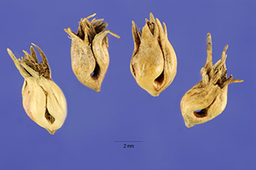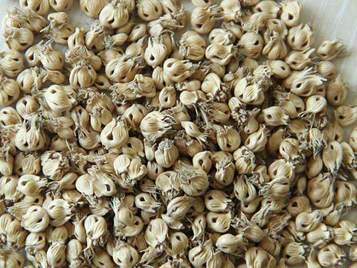

21.

When found in a sample of Kentucky bluegrass it is:
22. a. weed seed
b. crop seed
c. noxious weed

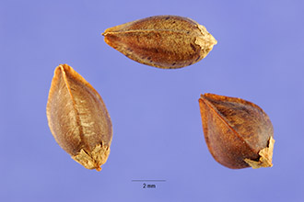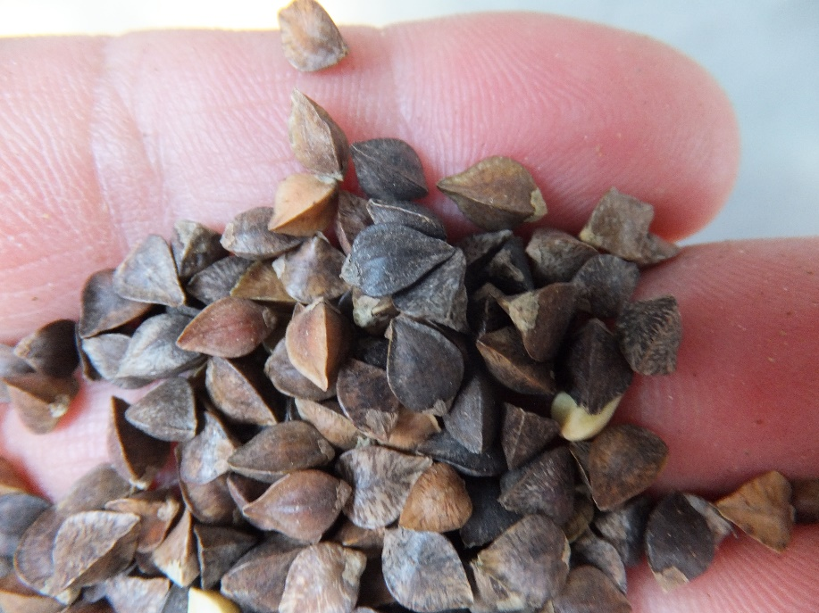

23.
When this seed is found in a sample of oats is:
24. a. weed seed
b. crop seed
c. noxious weed

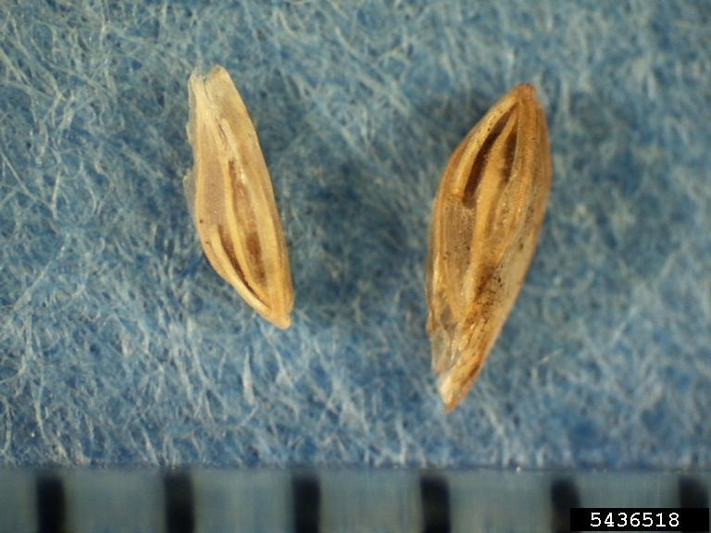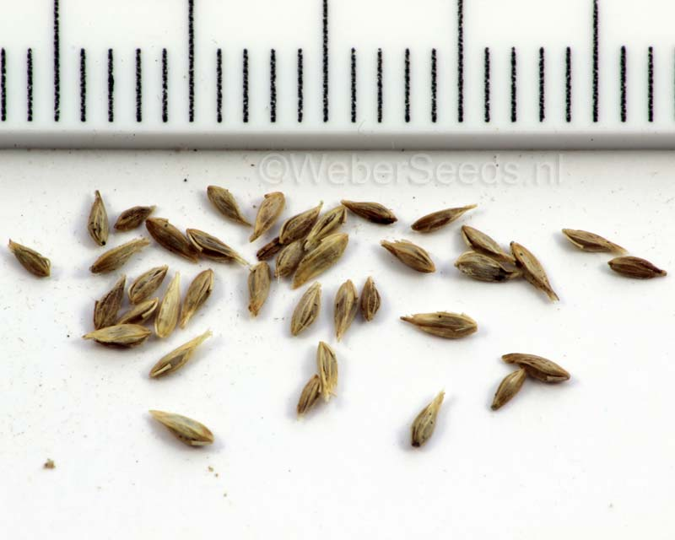

25.

When this seed is found in a sample of Kentucky bluegrass it is:
26. a. weed seed
b. crop seed
c. noxious weed

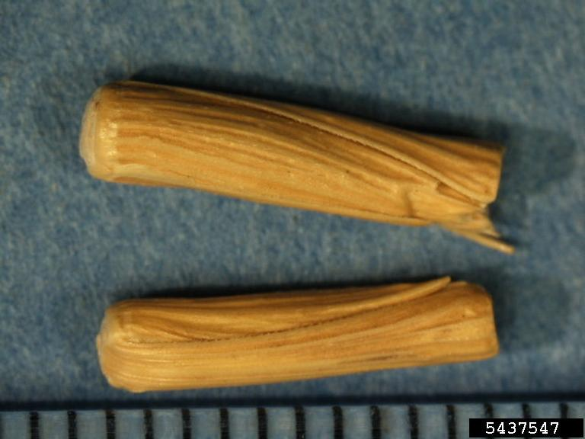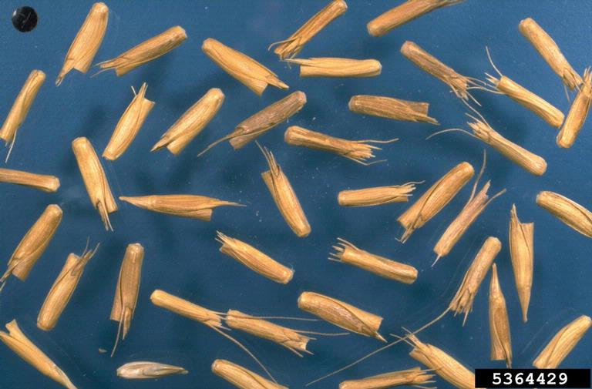

27.

When this seed found in a sample of intermediate wheatgrass is:
28. a. weed seed
b. crop seed
c. noxious weed

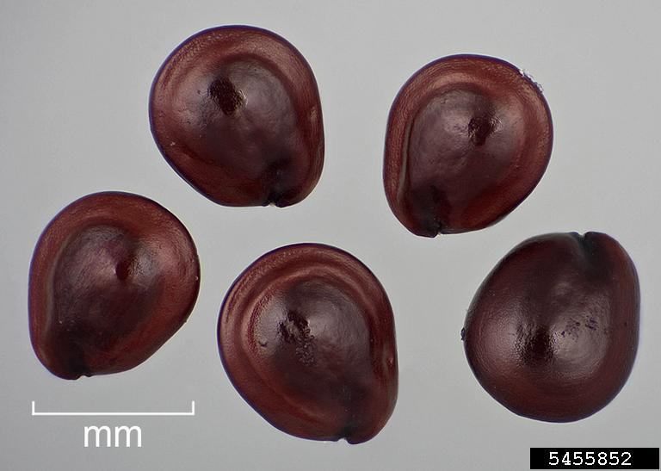 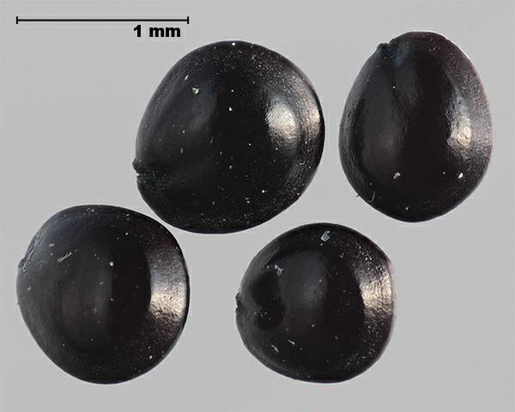.

29.

When this seed is found in a sample of sunflower is:
30. a. weed seed
b. crop seed
c. noxious weed

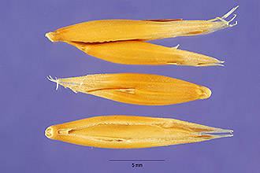

31. found in a sample of Indian rice grass is:
32. a. weed seed
b. crop seed
c. noxious weed

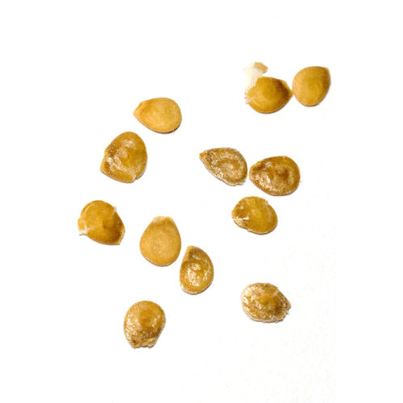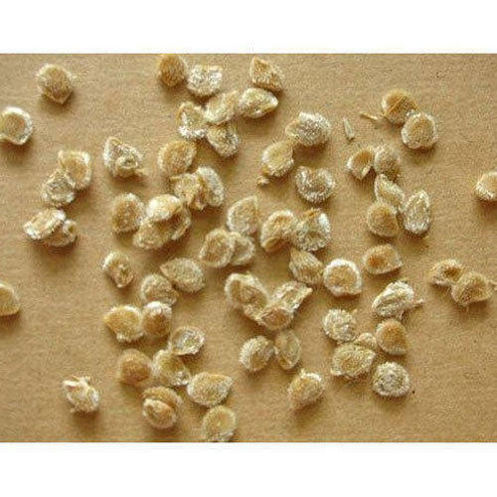
33. found in a sample of pepper is:
34. a. weed seed
b. crop seed
c. noxious weed

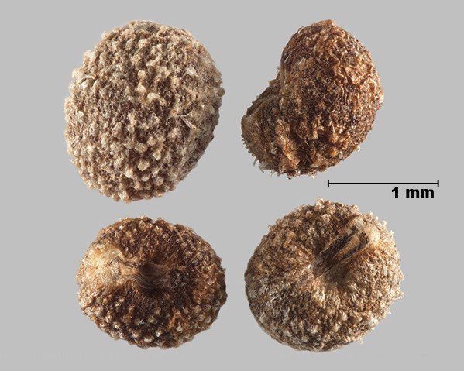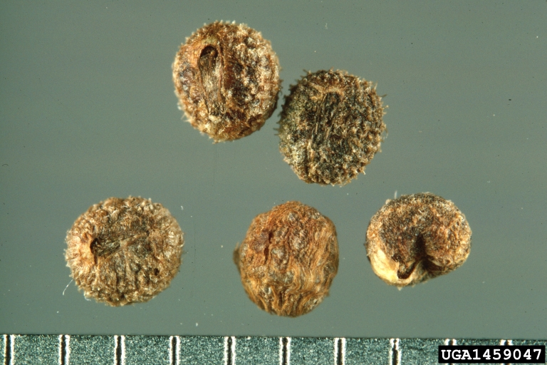

35. found in a sample of pepper is:
36. a. weed seed
b. crop seed
c. noxious weed

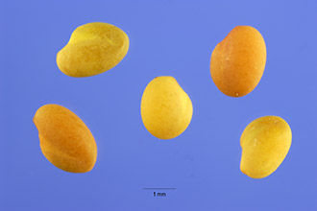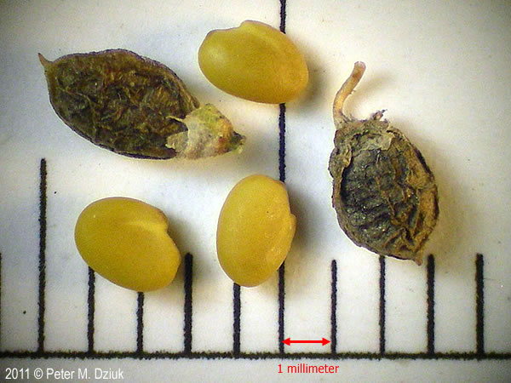

37. found in a sample of alfalfa is:
38. a. weed seed
b. crop seed
c. noxious weed

